**Karnaugh maps**

**Exercise 1 – Simplify** the following Boolean expressions using two different approaches:  
a)Minimisethe following Boolean expressions to **minimum terms** using **Boolean algebra theorems.**b) Draw the truth tables and the **Karnaugh maps** and minimize the logical functions as sums of products:

c) 

d) 

Solution:

**Exercise 2 –** **Simplify** the following Boolean expressions using two different approaches:  
a) Minimise the following Boolean expressions to **minimum terms** using **Boolean algebra theorems**.  
b) Draw the truth tables and the **Karnaugh maps** and minimize the logical functions as sums of products:

(c) 

(d) 

Solution:

1. b)

**c)**  d) 

**Exercise 3 –** Minimize the logical functions in the maps below as sums of products.

1. F1:



Solution:

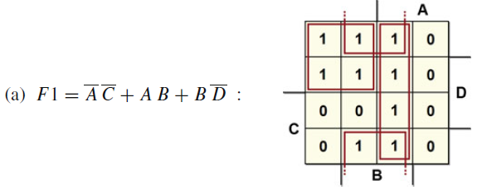

1. F2:



Solution:

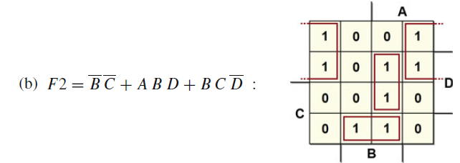

1. F3:



Solution:  
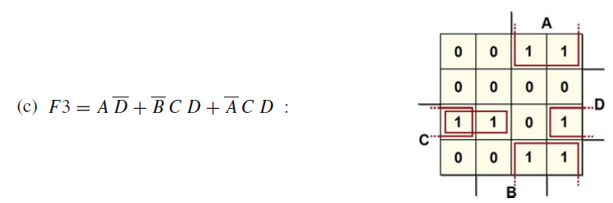

1. F4:



Solution:

**Exercise 4 –** Minimize the function as a sum of products, keeping in mind that inputs ABCD = “11−−” and ABCD = “−−11” are never present (combinations A = B = 1 or C = D = 1 can never arise).

Solution:  
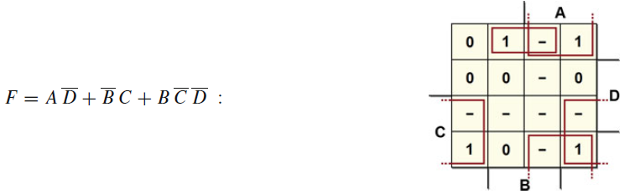

**Exercise 5 –** Synthesize the logical function in the map below as a sum of products.



Solution:

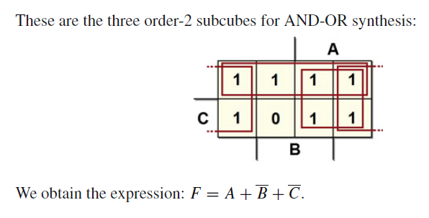

**Exercise 6 –** Synthesize the logical function in the map of the previous exercise as a product of sums.

Solution:

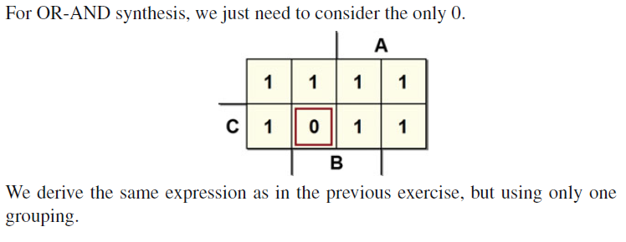

**Exercise 7 –** Synthesize the following map, which contains don’t-cares.



Solution:



**Exercise 8 –** Synthesize the following map.



Solution:  




**Exercise 9 –** Synthesize the following map and design the circuit.

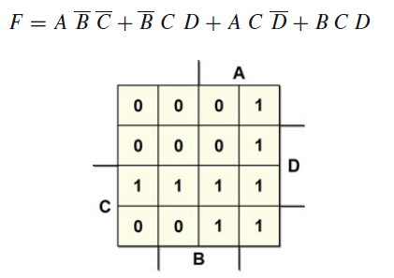

Solution:







**Exercise 10 –** Minimize each of the Boolean equations using the **Boolean Algebra** and then with the Karnaugh maps.

Solution:

**Exercise 11 –** Write the Boolean equations for the circuit in the figure. For the minimization see **exercise 12**.

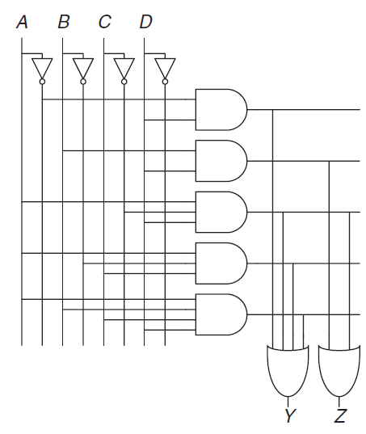

**Exercise 12 –** Minimize the Boolean equations from Exercise 11 using **Boolean Algebra** and then using   
**Karnaugh maps** and draw an improved circuit with the same function.

Solution:

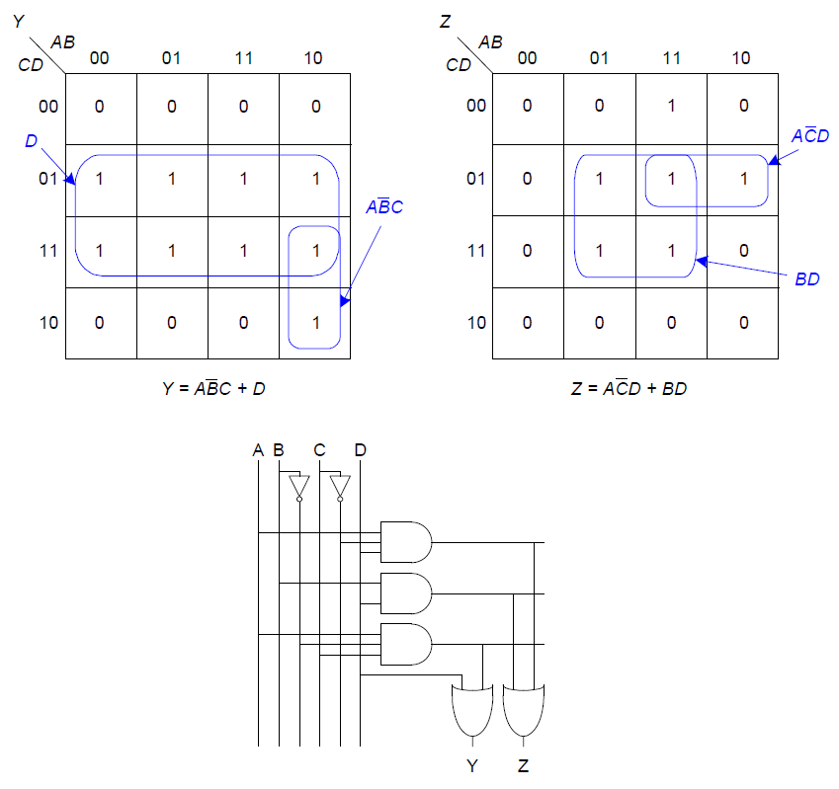

**Exercise 13 –** Find a minimal Boolean equation for the function in figure below with **Boolean Algebra** and **Karnaugh** **maps** (X = Don’t care).

Remember to take advantage of the don’t care entries.

Then draw the minimized circuit.

Solution:

